Hello and thank you for your recent health and nutrition product order. My name is Jonathan Glassman, and I've been assigned as your personal shop consultant. I'm here to answer any questions about our products or your order.

As a Market America customer, you may use the same login and password for all of our web sites.
These sites include: Shop.com, Isotonix, TLS Weight Loss Solution and Motives Cosmetics.

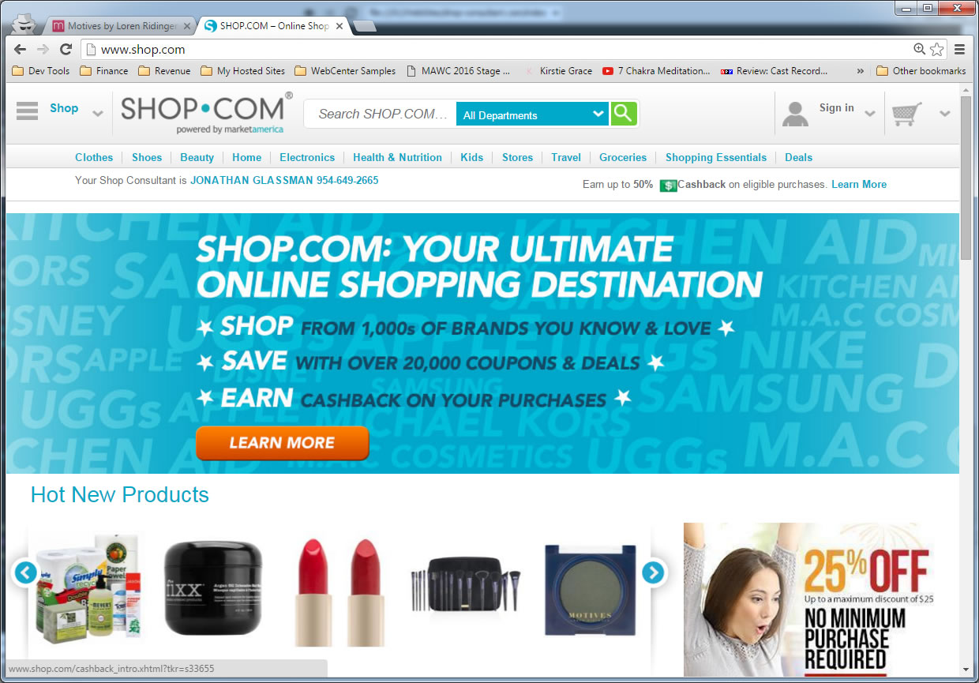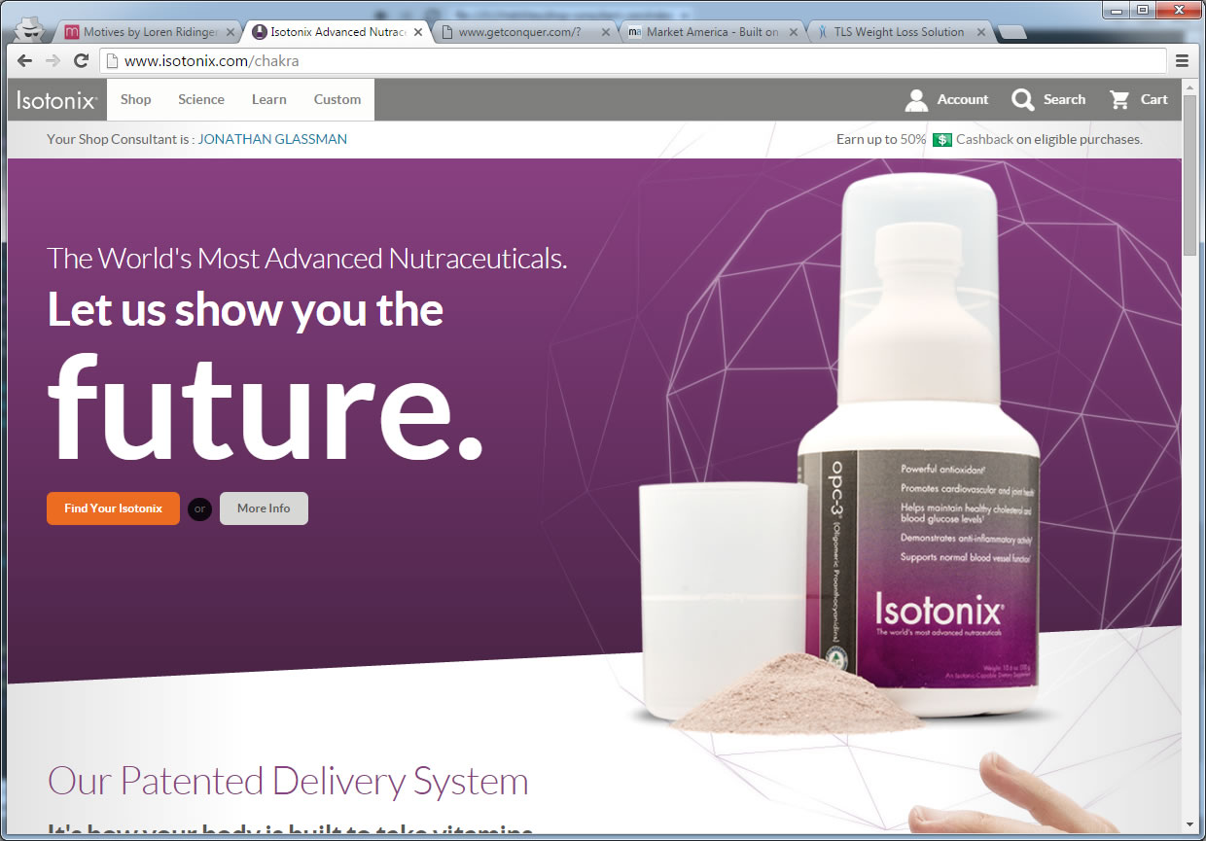

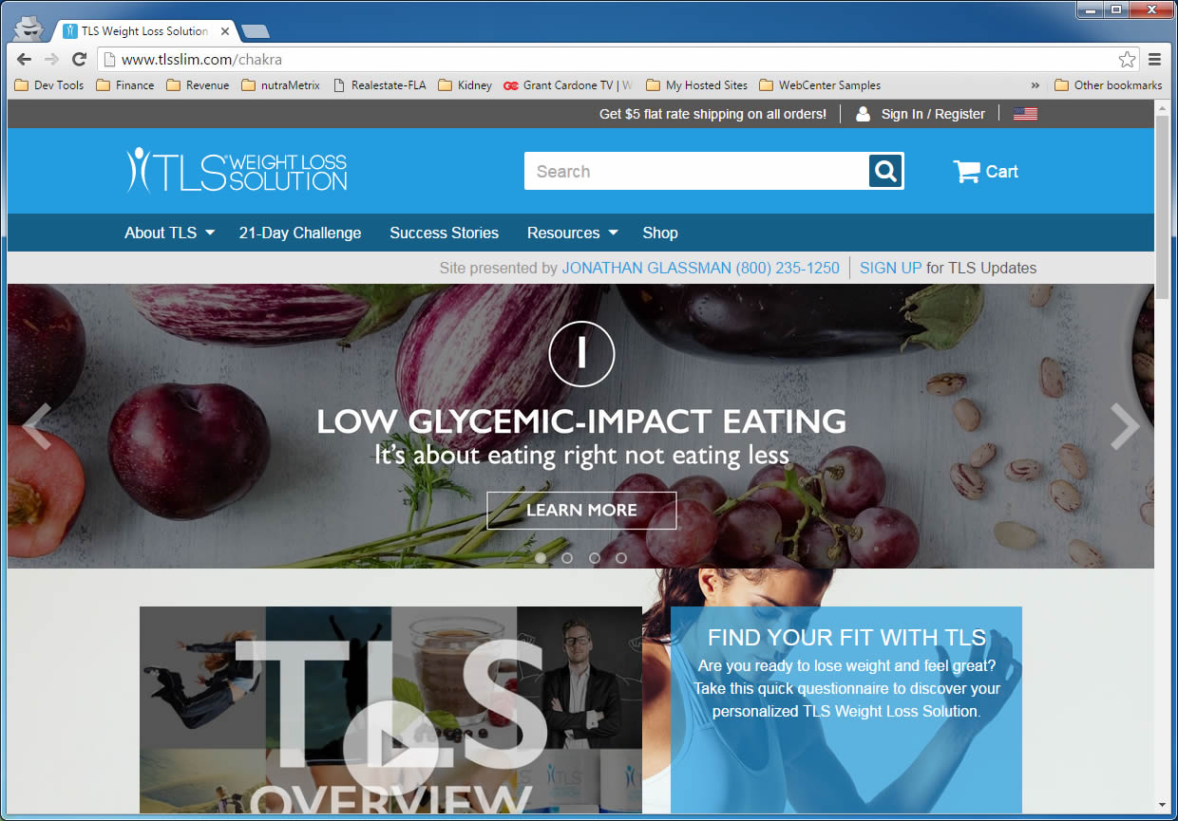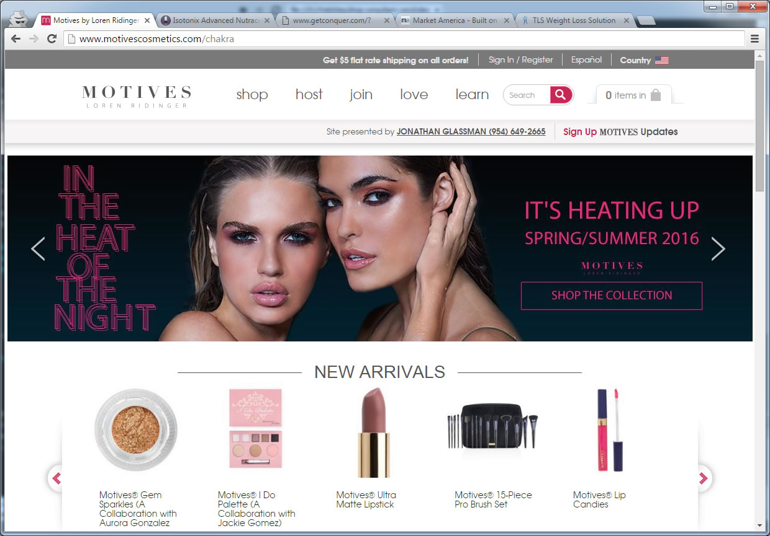

At Shop.com, you may browse all of our brands from over a dozen different divisions. Plus, you will have access to:
- Award Winning Search Technology: Search over 50 million products from thousands of stores.
- Cashback: Earn cashback on just about everything you buy.
- ShopBuddy: Install this browser extension to never miss a hot deal or cash back again.
- Shop Local: Earn cashback when you shop at thousands of local stores and restuarants.
- Hot Deals and Coupon Codes: We update over 12,000 hot deals and coupon codes daily.
- Price Alerts: Set Price Alerts to notify you when an item's price drops to the price you want to pay.
- eGifts: Not sure which gift to buy? Send an eGift. The recipient can then choose from a list you create.
- One Cart System: Check out from over 500 partner stores in a single transaction.
- Gift Registry: Perfect for weddings, babies, birthdays and holidays.
Please feel free to contact me anytime. I'm here to help ensure that you are able to get the most benefit from all these features. I look forward to being your personal shop consultant.

Thank You,
Jonathan Glassman / (800) 235-1250
www.Shop-Consultant.com

